**Lab 2: Build your VPC and Launch a Web Server**

**Lab overview and objectives**

In this lab, you will use Amazon Virtual Private Cloud (VPC) to create your own VPC and add additional components to produce a customized network. You will also create a security group. You will then configure and customize an EC2 instance to run a web server and you will launch the EC2 instance to run in a subnet in the VPC.

**Amazon Virtual Private Cloud (Amazon VPC)** enables you to launch Amazon Web Services (AWS) resources into a virtual network that you defined. This virtual network closely resembles a traditional network that you would operate in your own data center, with the benefits of using the scalable infrastructure of AWS. You can create a VPC that spans multiple Availability Zones.

After completing this lab, you should be able to do the following:

* Create a VPC.
* Create subnets.
* Configure a security group.
* Launch an EC2 instance into a VPC.

**Duration**

This lab takes approximately **30 minutes** to complete.

**AWS service restrictions**

In this lab environment, access to AWS services and service actions might be restricted to the ones that are needed to complete the lab instructions. You might encounter errors if you attempt to access other services or perform actions beyond the ones that are described in this lab.

**Scenario**

In this lab you build the following infrastructure:

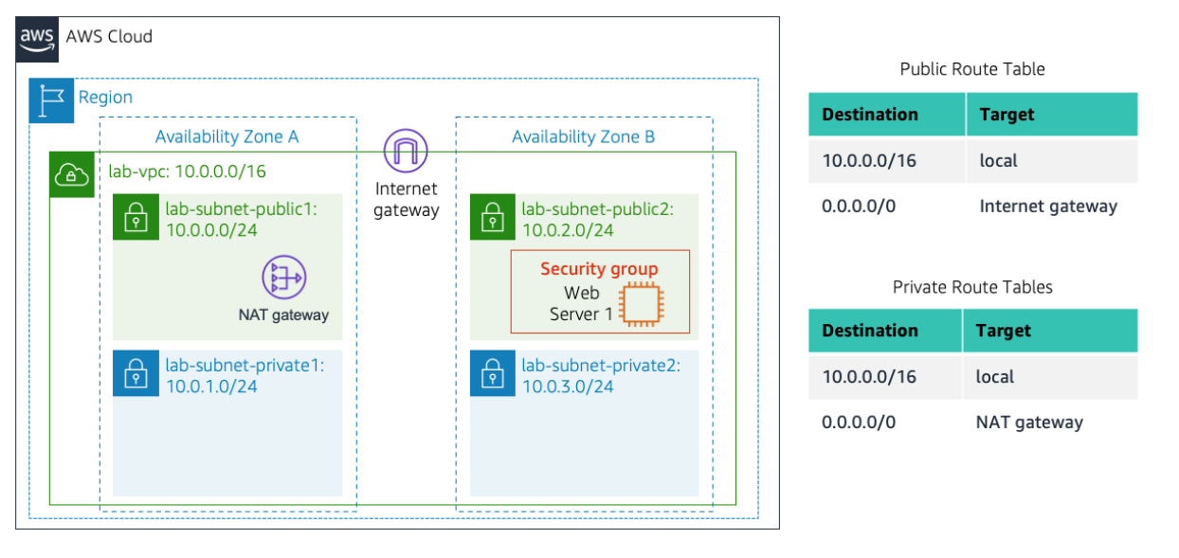

**Accessing the AWS Management Console**

1. At the top of these instructions, choose **Start Lab**.
   * The lab session starts.
   * A timer displays at the top of the page and shows the time remaining in the session.

**Tip:** To refresh the session length at any time, choose **Start Lab** again before the timer reaches 0:00.

* + Before you continue, wait until the circle icon to the right of the AWS link in the upper-left corner turns green.

1. To connect to the AWS Management Console, choose the **AWS** link in the upper-left corner.
   * A new browser tab opens and connects you to the console.

**Tip:** If a new browser tab does not open, a banner or icon is usually at the top of your browser with the message that your browser is preventing the site from opening pop-up windows. Choose the banner or icon, and then choose **Allow pop-ups**.

1. Arrange the AWS Management Console tab so that it displays along side these instructions. Ideally, you will be able to see both browser tabs at the same time, to make it easier to follow the lab steps.

**Getting Credit for your work**

At the end of this lab you will be instructed to submit the lab to receive a score based on your progress.

**Tip:** The script that checks you works may only award points if you name resources and set configurations as specified. In particular, values in these instructions that appear in This Format should be entered exactly as documented (case-sensitive).

**Task 1: Create Your VPC**

In this task, you will use the *VPC and more* option in the VPC console to create multiple resources, including a *VPC*, an *Internet Gateway*, a *public subnet* and a *private subnet* in a single Availability Zone, two *route tables*, and a *NAT Gateway*.

1. In the search box to the right of **Services**, search for and choose **VPC** to open the VPC console.
2. Begin creating a VPC.
   * In the top right of the screen, verify that **N. Virginia (us-east-1)** is the region.
   * Choose the **VPC dashboard** link which is towards the top left of the console.
   * Next, choose **Create VPC**.

**Note**: If you do not see a button with that name, choose the Launch VPC Wizard button instead.

1. Configure the VPC details in the *VPC settings* panel on the left:
   * Choose **VPC and more**.
   * Under **Name tag auto-generation**, keep *Auto-generate* selected, however change the value from project to lab.
   * Keep the **IPv4 CIDR block** set to 10.0.0.0/16
   * For **Number of Availability Zones**, choose **1**.
   * For **Number of *public* subnets**, keep the **1** setting.
   * For **Number of *private* subnets**, keep the **1** setting.
   * Expand the **Customize subnets CIDR blocks** section
     + Change **Public subnet CIDR block in us-east-1a** to 10.0.0.0/24
     + Change **Private subnet CIDR block in us-east-1a** to 10.0.1.0/24
   * Set **NAT gateways** to **In 1 AZ**.
   * Set **VPC endpoints** to **None**.
   * Keep both **DNS hostnames** and **DNS resolution** *enabled*.
2. In the *Preview* panel on the right, confirm the settings you have configured.
   * **VPC:** lab-vpc
   * **Subnets**:
     + us-east-1a
       - ***Public* subnet name:** lab-subnet-public1-us-east-1a
       - ***Private* subnet name:** lab-subnet-private1-us-east-1a
   * **Route tables**
     + lab-rtb-public
     + lab-rtb-private1-us-east-1a
   * **Network connections**
     + lab-igw
     + lab-nat-public1-us-east-1a
3. At the bottom of the screen, choose **Create VPC**

The VPC resources are created. The NAT Gateway will take a few minutes to activate.

Please wait until *all* the resources are created before proceding to the next step.

1. Once it is complete, choose **View VPC**

The wizard has provisioned a VPC with a public subnet and a private subnet in one Availability Zone with route tables for each subnet. It also created an Internet Gateway and a NAT Gateway.

To view the settings of these resources, browse through the VPC console links that display the resource details. For example, choose **Subnets** to view the subnet details and choose **Route tables** to view the route table details. The diagram below summarizes the VPC resources you have just created and how they are configured.

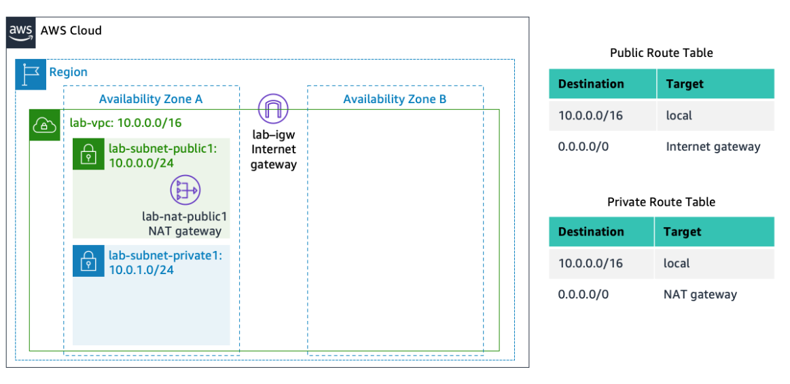

 An *Internet gateway* is a VPC resource that allows communication between EC2 instances in your VPC and the Internet.

The lab-subnet-public1-us-east-1a public subnet has a CIDR of **10.0.0.0/24**, which means that it contains all IP addresses starting with **10.0.0.x**. The fact the route table associated with this public subnet routes 0.0.0.0/0 network traffic to the internet gateway is what makes it a public subnet.

A *NAT Gateway*, is a VPC resource used to provide internet connectivity to any EC2 instances running in *private* subnets in the VPC without those EC2 instances needing to have a direct connection to the internet gateway.

The lab-subnet-private1-us-east-1a private subnet has a CIDR of **10.0.1.0/24**, which means that it contains all IP addresses starting with **10.0.1.x**.

**Task 2: Create Additional Subnets**

In this task, you will create two additional subnets for the VPC in a second Availability Zone. Having subnets in multiple Availability Zones within a VPC is useful for deploying solutions that provide *High Availability*.

After creating a VPC as you have already done, you can still configure it further, for example, by adding more **subnets**. Each subnet you create resides entirely within one Availability Zone.

1. In the left navigation pane, choose **Subnets**.

First, you will create a second *public* subnet.

1. Choose **Create subnet** then configure:
   * **VPC ID:** **lab-vpc** (select from the menu).
   * **Subnet name:** lab-subnet-public2
   * **Availability Zone:** Select the *second* Availability Zone (for example, us-east-1b)
   * **IPv4 CIDR block:** 10.0.2.0/24

The subnet will have all IP addresses starting with **10.0.2.x**.

1. Choose **Create subnet**

The second *public* subnet was created. You will now create a second *private* subnet.

1. Choose **Create subnet** then configure:
   * **VPC ID:** lab-vpc
   * **Subnet name:** lab-subnet-private2
   * **Availability Zone:** Select the *second* Availability Zone (for example, us-east-1b)
   * **IPv4 CIDR block:** 10.0.3.0/24

The subnet will have all IP addresses starting with **10.0.3.x**.

1. Choose **Create subnet**

The second *private* subnet was created.

You will now configure this new *private* subnet to route internet-bound traffic to the NAT Gateway so that resources in the second private subnet are able to connect to the Internet, while still keeping the resources private. This is done by configuring a *Route Table*.

A *route table* contains a set of rules, called *routes*, that are used to determine where network traffic is directed. Each subnet in a VPC must be associated with a route table; the route table controls routing for the subnet.

1. In the left navigation pane, choose **Route tables**.
2. Select the **lab-rtb-private1-us-east-1a** route table.

**Note:** If the newly created routes are not visible, choose refresh button at the top to update the list of routes.

1. In the lower pane, choose the **Routes** tab.

Note that **Destination 0.0.0.0/0** is set to **Target nat-xxxxxxxx**. This means that traffic destined for the internet (0.0.0.0/0) will be sent to the NAT Gateway. The NAT Gateway will then forward the traffic to the internet.

This route table is therefore being used to route traffic from private subnets.

1. Choose the **Subnet associations** tab.

You created this route table in task 1 when you chose to create a VPC and multiple resources in the VPC. That action also created *lab-subnet-private-1* and associated that subnet with this route table.

Now that you have created another private subnet, lab-subnet-private-2, you will associate this route table with that subnet as well.

1. In the Explicit subnet associations panel, choose **Edit subnet associations**
2. Leave **lab-subnet-private1-us-east-1a** selected, but also select **lab-subnet-private2**.
3. Choose **Save associations**

You will now configure the Route Table that is used by the Public Subnets.

1. Select the **lab-rtb-public** route table (and deselect any other subnets).
2. In the lower pane, choose the **Routes** tab.

Note that **Destination 0.0.0.0/0** is set to Target **igw-xxxxxxxx**, which is an Internet Gateway. This means that internet-bound traffic will be sent straight to the internet via this Internet Gateway.

You will now associate this route table to the second public subnet you created.

1. Choose the **Subnet associations** tab.
2. In the Explicit subnet associations area, choose **Edit subnet associations**
3. Leave **lab-subnet-public1-us-east-1a** selected, but also select **lab-subnet-public2**.
4. Choose **Save associations**

Your VPC now has public and private subnets configured in two Availability Zones. The route tables you created in task 1 have also been updated to route network traffic for the two new subnets.

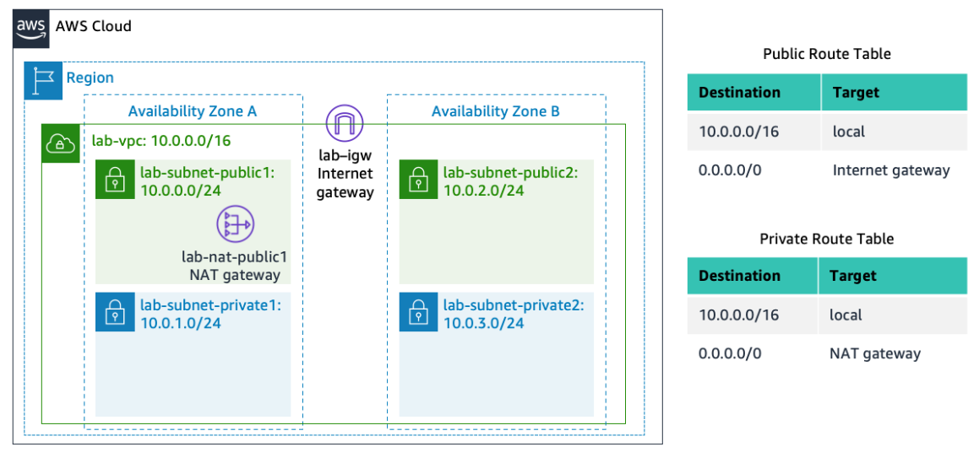

**Task 3: Create a VPC Security Group**

In this task, you will create a VPC security group, which acts as a virtual firewall. When you launch an instance, you associate one or more security groups with the instance. You can add rules to each security group that allow traffic to or from its associated instances.

1. In the left navigation pane, choose **Security groups**.
2. Choose **Create security group** and then configure:
   * **Security group name:** Web Security Group
   * **Description:** Enable HTTP access
   * **VPC:** choose the X to remove the currently selected VPC, then from the drop down list choose **lab-vpc**
3. In the **Inbound rules** pane, choose **Add rule**
4. Configure the following settings:
   * **Type:** *HTTP*
   * **Source:** *Anywhere-IPv4*
   * **Description:** Permit web requests
5. Scroll to the bottom of the page and choose **Create security group**

You will use this security group in the next task when launching an Amazon EC2 instance.

**Task 4: Launch a Web Server Instance**

In this task, you will launch an Amazon EC2 instance into the new VPC. You will configure the instance to act as a web server.

1. In the search box to the right of **Services**, search for and choose **EC2** to open the EC2 console.
2. From the **Launch instance** menu choose **Launch instance**.
3. Name the instance:
   * Give it the name Web Server 1

When you name your instance, AWS creates a tag and associates it with the instance. A tag is a key value pair. The key for this pair is ***\*Name\****, and the value is the name you enter for your EC2 instance.

1. Choose an AMI from which to create the instance:
   * In the list of available *Quick Start* AMIs, keep the default **Amazon Linux** selected.
   * Also keep the default **Amazon Linux 2023 AMI** selected.

The type of *Amazon Machine Image (AMI)* you choose determines the Operating System that will run on the EC2 instance that you launch.

1. Choose an Instance type:
   * In the *Instance type* panel, keep the default **t2.micro** selected.

The *Instance Type* defines the hardware resources assigned to the instance.

1. Select the key pair to associate with the instance:
   * From the **Key pair name** menu, select **vockey**.

The vockey key pair you selected will allow you to connect to this instance via SSH after it has launched. Although you will not need to do that in this lab, it is still required to identify an existing key pair, or create a new one, or choose to proceed without a key pair, when you launch an instance.

1. Configure the Network settings:
   * Next to Network settings, choose **Edit**, then configure:
     + **Network:** *lab-vpc*
     + **Subnet:** *lab-subnet-public2* (*not* Private!)
     + **Auto-assign public IP:** *Enable*
   * Next, you will configure the instance to use the *Web Security Group* that you created earlier.
     + Under Firewall (security groups), choose **Select existing security group**.
     + For **Common security groups**, select **Web Security Group**.

This security group will permit HTTP access to the instance.

1. In the *Configure storage* section, keep the default settings.

**Note**: The default settings specify that the *root volume* of the instance, which will host the Amazon Linux guest operating system that you specified earlier, will run on a general purpose SSD (*gp3*) hard drive that is 8 GiB in size. You could alternatively add more storage volumes, however that is not needed in this lab.

1. Configure a script to run on the instance when it launches:
   * Expand the **Advanced details** panel.
   * Scroll to the bottom of the page and then copy and paste the code shown below into the **User data** box:



#!/bin/bash

# Install Apache Web Server and PHP

dnf install -y httpd wget php mariadb105-server

# Download Lab files

wget https://aws-tc-largeobjects.s3.us-west-2.amazonaws.com/CUR-TF-100-ACCLFO-2/2-lab2-vpc/s3/lab-app.zip

unzip lab-app.zip -d /var/www/html/

# Turn on web server

chkconfig httpd on

service httpd start

This script will run with root user permissions on the guest OS of the instance. It will run automatically when the instance launches for the first time. The script installs a web server, a database, and PHP libraries, and then it downloads and installs a PHP web application on the web server.

1. At the bottom of the **Summary** panel on the right side of the screen choose **Launch instance**

You will see a Success message.

 Choose **View all instances**

1. Wait until **Web Server 1** shows *2/2 checks passed* in the **Status check** column.

This may take a few minutes. Choose the refresh icon at the top of the page every 30 seconds or so to more quickly become aware of the latest status of the instance.

You will now connect to the web server running on the EC2 instance.

1. Select **Web Server 1**.
2. Copy the **Public IPv4 DNS** value shown in the **Details** tab at the bottom of the page.
3. Open a new web browser tab, paste the **Public DNS** value and press Enter.

You should see a web page displaying the AWS logo and instance meta-data values.

The complete architecture you deployed is:

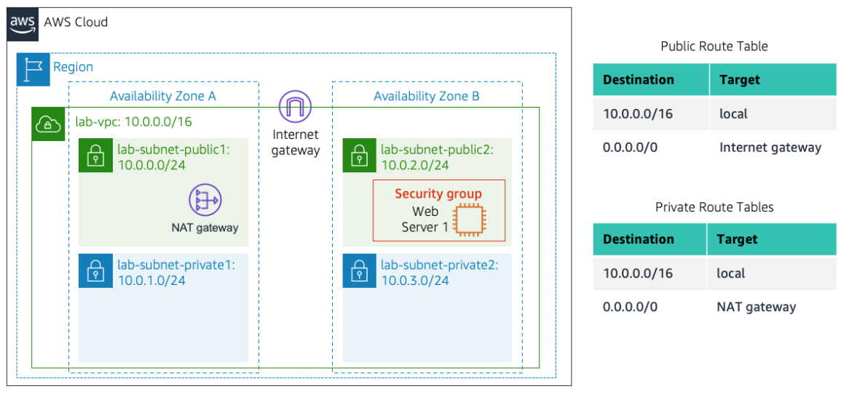

**Submitting your work**

1. To record your progress, choose **Submit** at the top of these instructions.
2. When prompted, choose **Yes**.

After a couple of minutes, the grades panel appears and shows you how many points you earned for each task. If the results don't display after a couple of minutes, choose **Grades** at the top of these instructions.

**Tip:** You can submit your work multiple times. After you change your work, choose **Submit** again. Your last submission is recorded for this lab.

1. To find detailed feedback about your work, choose **Submission Report**.

**Tip:** For any checks where you did not receive full points, there are sometimes helpful details provided in the submission report.

**Lab complete**

Congratulations! You have completed the lab.

1. Choose **End Lab** at the top of this page, and then select **Yes** to confirm that you want to end the lab.

A panel indicates that *You may close this message box now...*

1. Select the **X** in the top-right corner to close the panel.

© 2023, Amazon Web Services, Inc. and its affiliates. All rights reserved. This work may not be reproduced or redistributed, in whole or in part, without prior written permission from Amazon Web Services, Inc. Commercial copying, lending, or selling is prohibited.